ECE241 Final Project Report – **Beatmaker**

**Introduction**

For our project, we created an audio beat player, customized with 8 different samples, which can both record and playback a combination of beats. The motivation for this project was inspired from MIDI-kits, the 808-Rhythm Composer, and other digital drum kits. With a simple interface, one can create a large variety of songs, melodies, depending on which samples they use.

The goals we prepared were:

1. Prepare audio samples – have them play on keypress, and recording keypresses
2. Have all audio samples, recording working with all keys and playing back recordings
3. Connect keypresses and playback module to VGA, lighting up images if a sound is playing

During the process, we worked with implementing memory on the DE1-SOC Board on a much larger scale than we had before in our labs. Using the ROMs on the board, we were able to use converted audio files and pictures in our design.

A short demo of the project is available here:  
https://drive.google.com/file/d/1JlrNIlYyaDrnijkrWSHl_wOkfAwdN5bG/

**The Design**

The design for the Beatmaker consisted of multiple modules, shown below in a simplified block diagram:

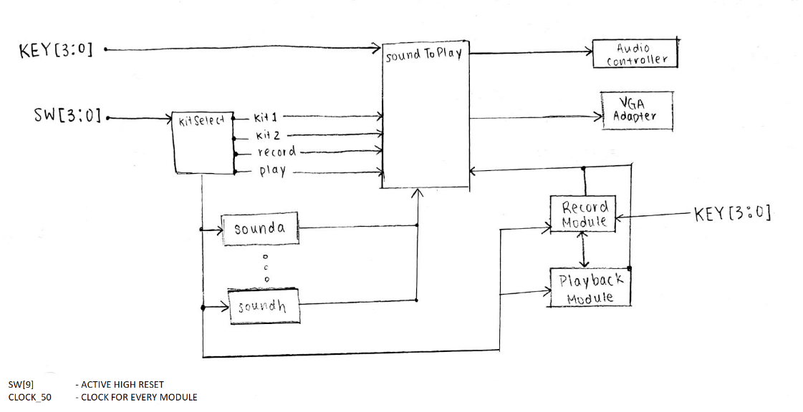  
[Appendix B]

Description of each component:

* **Top Module** [Appendix C]:
  + Connects all components/modules together
  + Contains wiring connecting soundToPlay Module to the audio controller as well as the VGA Adapter
* **kitSelect Module** [Appendix D]:
  + Multiplexor which determines state of circuit depending on which switches are on:
    - Which kit the user is using for playing sound (kit1, kit2)
    - Whether the user is recording, playing back, or neither
* **Sound Modules** [Appendix E]:
  + Contains ROM with ‘.mif’ raw audio data stored
  + Has counter to send out ROM data when triggered with its respective ‘play’ signal
  + There are 8 of these modules, each for a different sound sample
* **soundToPlay Module** [Appendix F]:
  + Takes in all keypresses and decoded playback signals
  + Determines which Sound Module to send ‘play’ signals, to play their respective sound when triggered
  + Outputs are connected to the audio controller directly, which plays the sounds
* **Record Module** [Appendix G]:
  + Records keypresses every tenth of a second, using a counter with the built-in clock
  + Encodes keypresses for each possible sound to store into a 4-bit RAM:
    - 9 different codes for 8 sounds and 1 for no sound
    - Encoding method can be seen in the Appendix code
    - Used for playback of sounds in the same manner
  + Plays metronome click every half-second for timekeeping
  + Has two channel settings for 12 or 24 seconds of recording
  + Connects to HEX displays to show timer (in base 10)
* **Playback Module** [Appendix H]:
  + Has counter which sifts through recorded data and decodes it
  + Sends playback signals for each sound back to soundToPlay Module
* **VGA Modules** [Appendix I] [Appendix J]:
  + Displays an intro screen (160x120) with numbers 1-8 for each sound sample
  + Prints record and playback images
  + Each image will light up when pressed/played/toggled (Did not work in final demo)
  + Outputs signals for position and color to the VGA adapter

**Report on Success**

The development of the main components for our project was successful. The main portion of our project worked as intended: a functioning audio beat player, which can play 8 different samples, as well as both record and playback a combination of beats:

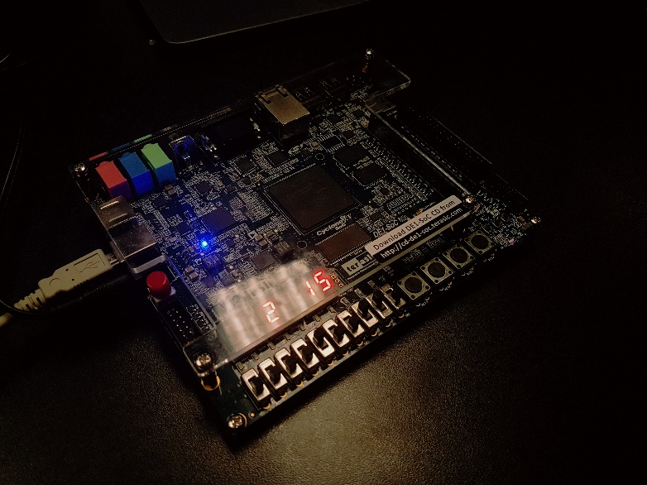  
Project on Record mode 2nd Channel – Counting to 24 seconds

We were able to finish these parts of the design in the first two weeks, and, as a result, we were able to add an extra milestone for an additional feature to the game: using the VGA for playback and record images, as well as numbers 1-8 which would show the player which settings were toggled, and which sounds were playing [Appendix I] [Appendix J]. Unfortunately, this feature was not fully implemented – mainly due to bugs and time constraints.

The audio components were simple to work with at first, using the audio demo provided. Most of the difficulty for the audio controller was connecting different sounds, converting audio into a raw binary format, which would be plugged into a 1-PORT ROM. The ROMs were read with counters triggered from keypresses or recording data. In addition, we were able to add extra features, including two channels for recording (12 or 24 seconds) and a metronome to play during the recording state [Appendix G].

The main problem that we had during the building of our project was that the features implemented on the VGA could not be completed in time. We were attempting to use a separate FSM and control path to select and change the color of each number printed on the screen, which would indicate when each sound or beat was being played.

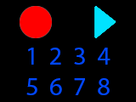  
Image of VGA background

When toggling the record or playback switches, the matching image on the screen would have changed color. The same would occur for when the sounds were playing. We speculated that the main bugs were with the handshake signals, which were supposed to be passed between the audio and VGA modules. While we passed in signals for recording, playing back, and each sound, the monitor did not respond – nothing was printed onto the screen. In the end, we felt this was both an issue of time and improper testing, with the complexity of the VGA portion of the design.

**What could have been done differently**

Reflecting on how we could done this project differently, our team definitely agreed time management and communication was an issue. The work was not split properly, as discussed in the meeting with the TA, which led to delayed testing of much of the VGA portion of the project. One member (Gaoxing Ding) was responsible for implementing the VGA [Appendix I] [Appendix J], while the other (Eun Koo) was responsible for the audio implementation, recording/playback, and, for the third week, extra features, such as the metronome, timer, and recording channels [Appendix C] [Appendix D] [Appendix E] [Appendix F] [Appendix G] [Appendix H].

Our team decided to implement the VGA feature to our project after the second week of development. This was mainly due to us finishing the record and playback features much quicker than expected. If we had planned for a fully integrated VGA with our audio, it could have been possible to add a better user interface, and possibly support for other features, such as adding more sounds with a keyboard, while finishing on time.

Most of the work for the VGA feature was done by one of our team members, as mentioned above, while the other worked on adding more features for the audio portion. Unfortunately, the coding process during the last week was rushed. Over 500 lines of code (partly recycled from previous lab assignments) were written [Appendix I] [Appendix J]. Initial testing of the code was only done after everything was written. We could have improved on this process by testing the code as we went along, instead of doing it all close to the deadline.

Another possible change was that we felt that if we had decided on our goals at an earlier point in time, this problem could have been avoided. One of the main reasons we did not prepare for this was because the record and playback features of the design were expected to take much longer to develop. Being our first design project in the course, and digital logic in general, there was a lot to learn from a project management perspective which resulted in a rush to complete the project before the deadline. With some more time, we felt could have successfully added animations and moving components onto the screen for the VGA portion. Ultimately, we compromised by displaying an intro screen for the different features of our design (record, playback, 8 sounds).

In addition, an extra feature we wanted to work with was an SD card for storage. This way, we could record the audio and have the data saved onto an external memory, which could be used elsewhere. This would have made our design much more practical and interesting. Unfortunately, our team agreed that using the SD card was going to be too difficult after researching various methods for implementation, many of which required the use of Qsys and coding in languages other than Verilog.

**Conclusion**

The project successfully demonstrated use of the DE1-SOC Board’s memory, audio and VGA controllers with the implementation of a functioning audio beat player, which can play 8 different samples, as well as both recording and playing back a combination of beats. In the process, we learned how to work with memory cells for both the audio and VGA portions, and with abstraction on a large scale, with multiple FSMs, data paths, and multiplexors all intertwined and interacting in the process.

**Appendix – Diagrams, Schematics, Code**

**Appendix A** – Quartus Schematic for design

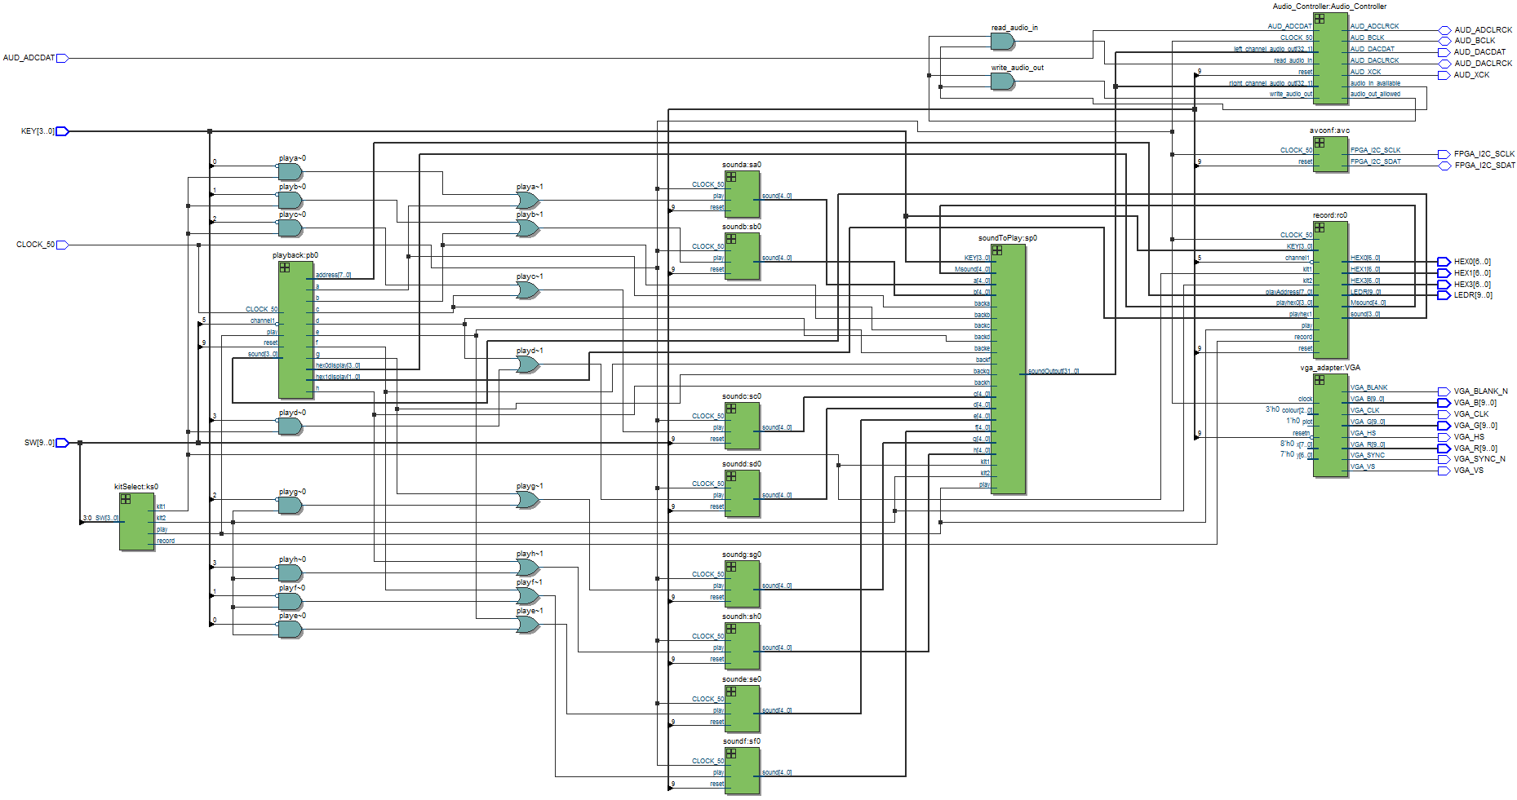

**Appendix B** – Simplified Schematic / Block Diagram

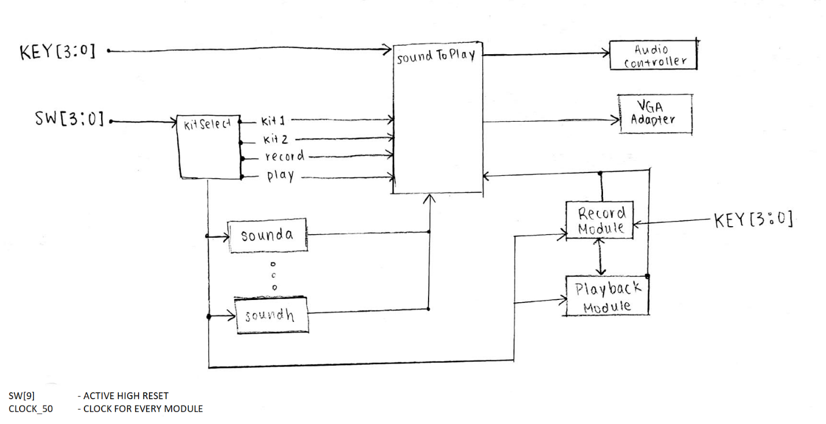

**Appendix C** – Top Module code (Audio, VGA demo, redundant code was deleted – marked by **\*\*\*_\*\*\***)

module top (*AUDIO CODE*, *VGA CODE*, **\*\*\*REST OF INPUTS MARKED DOWN BELOW\*\*\***);

**\*\*\*AUDIO AND VIDEO INPUTS/OUTPUTS\*\*\***

// Inputs

input CLOCK_50;

input [3:0] KEY;

input [9:0] SW;

output [6:0] HEX0, HEX1, HEX3;

output [9:0] LEDR;

// Internal Wires

wire audio_in_available;

wire [31:0] left_channel_audio_in;

wire [31:0] right_channel_audio_in;

wire read_audio_in;

wire audio_out_allowed;

wire [31:0] left_channel_audio_out;

wire [31:0] right_channel_audio_out;

wire write_audio_out;

// My inputs and outputs

wire kit1, kit2, record, play;

kitSelect ks0(SW, kit1, kit2, record, play);

// Sound Modules

wire playa, donea;

assign playa = ((kit1 & ~KEY[0]) | backa);

wire [4:0] sounda;

sounda sa0(CLOCK_50, SW[9], playa, sounda, donea);

wire playb, doneb;

assign playb = ((kit1 & ~KEY[1]) | backb);

wire [4:0] soundb;

soundb sb0(CLOCK_50, SW[9], playb, soundb, doneb);

**\*\*\*REDUNDANT CODE\*\*\***

wire playh, doneh;

assign playh = ((kit2 & ~KEY[3]) | backh);

wire [4:0] soundh;

soundh sh0(CLOCK_50, SW[9], playh, soundh, doneh);

wire [31:0] soundOutput;

soundToPlay sp0(KEY, kit1, kit2, play, backa, backb, backc, backd, backe, backf, backg, backh, sounda, soundb, soundc, soundd, sounde, soundf, soundg, soundh, Msound, soundOutput);

// Record Module

wire [3:0] recSound;

wire [4:0] Msound;

record rc0(CLOCK_50, SW[9], KEY, record, play, kit1, kit2, !SW[5], playAddress, playhex0, playhex1, recSound, HEX0, HEX1, HEX3, LEDR, Msound);

// Playback Module

wire [7:0] playAddress;

wire [3:0] playhex0;

wire [1:0] playhex1;

wire backa, backb, backc, backd, backe, backf, backg, backh;

playback pb0(CLOCK_50, SW[9], play, recSound, !SW[5], backa, backb, backc, backd, backe, backf, backg, backh, playAddress, playhex0, playhex1);

// VGA Modules

**\*\*\*DID NOT END UP WORKING\*\*\***

wire clearSignal;

wire [7:0] ld;

wire vgaClear, waiting;

vgaFSM vf0 (CLOCK_50, SW[9], KEY, kit1, kit2, play, {backa, backb, backc, backd, backe, backf, backg, backh}, drawDone, clearSignal, ld, vgaClear, waiting);

wire vgaWrite;

wire drawDone;

wire [2:0] vgaOutput;

wire [7:0] x;

wire [6:0] y;

datapath dp0(CLOCK_50, reset, ld, vgaClear, waiting, vgaWrite, vgaOutput, drawDone, clearSignal, x, y);

assign read_audio_in = audio_in_available & audio_out_allowed;

assign left_channel_audio_out = soundOutput;

assign right_channel_audio_out = soundOutput;

assign write_audio_out = audio_in_available & audio_out_allowed;

**\*\*\*AUDIO CONTROLLER AND VGA ADAPTER\*\*\***

endmodule

**Appendix D** – kitSelect Module code (Redundant code was deleted – marked by **\*\*\*_\*\*\***)

module kitSelect (SW, kit1, kit2, record, play);

input [3:0] SW;

output reg kit1, kit2, record, play;

// Manages different states for switches - record, play, kit1-2

always @(*) begin

if (SW[0] & !SW[1] & !SW[2] & !SW[3]) begin

kit1 = 1;

kit2 = 0;

record = 0;

play = 0;

end

else if (SW[1] & !SW[0] & !SW[2] & !SW[3]) begin

kit1 = 0;

kit2 = 1;

record = 0;

play = 0;

end

else if (SW[2] & !SW[0] & !SW[1] & !SW[3]) begin

kit1 = 0;

kit2 = 0;

record = 1;

play = 0;

end

**\*\*\*REDUNDANT CODE\*\*\***

else begin

kit1 = 0;

kit2 = 0;

record = 0;

play = 0;

end

end

endmodule

**Appendix E** – Sound A Module (Same format for all sound modules)

module sounda (CLOCK_50, reset, play, sound, done);

input CLOCK_50;

input reset;

input play;

output [4:0] sound;

output reg done;

reg [11:0] counter;

reg [8:0] address;

reg start;

localparam final = 9'b100111100;

// Counter for extracting audio data

always @(posedge CLOCK_50) begin

if (play)

start <= 1;

if (reset) begin

counter <= 0;

address <= 0;

done <= 0;

start <= 0;

end

else if (done & start) begin

counter <= 0;

address <= 0;

done <= 0;

start <= 0;

end

else if (counter == 12'b100000100100 & start) begin

counter <= 0;

if (address != final)

address <= address + 1;

else

done <= 1;

end

else if (start)

counter <= counter + 1;

end

a a_inst (

.address ( address ),

.clock ( CLOCK_50 ),

.q ( sound ) // Add 20 - 23 0s at the end

);

endmodule

**Appendix F** – soundToPlay Module code

module soundToPlay (KEY, kit1, kit2, play, backa, backb, backc, backd, backe, backf, backg, backh, a, b, c, d, e, f, g, h, Msound, soundOutput);

input [3:0] KEY;

input kit1, kit2, play;

input backa, backb, backc, backd, backe, backf, backg, backh;

input [4:0] a, b, c, d, e, f, g, h, Msound;

output [31:0] soundOutput;

reg [4:0] sounda;

reg [4:0] soundb;

always @(!play) begin

case (~KEY)

4'b0000: sounda = Msound;

4'b0001: sounda = kit1 ? a : kit2 ? e : 0;

4'b0010: sounda = kit1 ? b : kit2 ? f : 0;

4'b0100: sounda = kit1 ? c : kit2 ? g : 0;

4'b1000: sounda = kit1 ? d : kit2 ? h : 0;

default: sounda = 0;

endcase

end

always @(play) begin

if (backa)

soundb = a;

else if (backb)

soundb = b;

else if (backc)

soundb = c;

else if (backd)

soundb = d;

else if (backe)

soundb = e;

else if (backf)

soundb = f;

else if (backg)

soundb = g;

else if (backh)

soundb = h;

else

soundb = 0;

end

assign soundOutput = {play ? soundb : sounda, 21'b0};

endmodule

**Appendix G** – Record Module code

module record (**\*\*\*INPUTS WHICH ARE EITHER REDUNDANT/LISTED BELOW\*\*\***);

input record, play, kit1, kit2;

// Two recording channels determined by this input

input channel1;

input [7:0] playAddress;

input [3:0] playhex0;

input playhex1;

output [3:0] sound;

output [6:0] HEX0, HEX1, HEX3;

output [9:0] LEDR;

// Hold sound data to be recorded

reg [3:0] keySound;

reg [3:0] recKey;

reg recDone;

// RateDividing / Counter

reg [22:0] counter; // Counts to 10011000100101101000000 = 5 mill.

reg [7:0] address;

// For Metronome feature

reg [2:0] Mcounting;

reg Mplay;

output [4:0] Msound;

// Timer for time keeping in base10

reg [3:0] hex0timer;

reg [3:0] hex0display;

reg [1:0] hex1display;

// Counts to 12 or 24

localparam final = channel1 ? 8'b01111000 : 8'b11110000, Mfinal = 12'b110111001000;

// Assigns 4-bit for every sound

always @(*) begin

case (~KEY)

**4'b0001: keySound = kit1 ? 4'b0001 : 4'b1001;**

**4'b0010: keySound = kit1 ? 4'b0010 : 4'b1010;**

**4'b0100: keySound = kit1 ? 4'b0100 : 4'b1100;**

**4'b1000: keySound = kit1 ? 4'b0111 : 4'b1111;**

endcase

end

always @(posedge CLOCK_50) begin

if (reset) begin

counter <= 0;

address <= 0;

recDone <= 0;

recKey <= 0;

hex0timer <= 0;

hex0display <= 0;

hex1display <= 0;

Mcounting <= 0;

Mplay <= 0;

end

else if (record & !recDone) begin

// 0.1 second

if (counter == 23'b10011000100101101000000) begin

counter <= 0;

hex0timer <= hex0timer + 1;

Mcounting <= Mcounting + 1;

if (Mplay)

Mplay <= 0;

else if (Mcounting == 3'b101) begin

Mcounting <= 0;

Mplay <= 1;

end

if (address == (channel1 ? 8'b01111000 : 8'b11110000))

recDone <= 1;

else

address <= address + 1;

recKey <= 0;

end

else begin

counter <= counter + 1;

if (~KEY)

recKey <= keySound;

end

if (hex0timer == 4'b1010) begin

hex0timer <= 0;

hex0display <= hex0display + 1;

end

if (hex0display == 4'b1010) begin

hex0display <= 0;

hex1display <= hex1display + 1;

end

end

end

// Metronome Component

reg Mstart, Mdone;

reg [11:0] Mcounter;

reg [11:0] Maddress;

always @(posedge CLOCK_50) begin

if (Mplay)

Mstart <= 1;

if (reset) begin

Mcounter <= 0;

Maddress <= 0;

Mdone <= 0;

Mstart <= 0;

end

else if (Mdone & Mstart & record) begin

Mcounter <= 0;

Maddress <= 0;

Mdone <= 0;

Mstart <= 0;

end

else if (Mcounter == 12'b100000100100 & Mstart & record) begin

Mcounter <= 0;

if (Maddress != Mfinal)

Maddress <= Maddress + 1;

else

Mdone <= 1;

end

else if (Mstart & record)

Mcounter <= Mcounter + 1;

end

// Memory module with 128 words x 1-bit

RecordMemory recordmem (

// Make this use the same address counter - repeitive code

.address (record ? address : playAddress),

.clock (CLOCK_50),

.data (record ? recKey : 0),

.wren (record ? 1 : 0),

.q (sound)

);

metronome mn0 (

.address (Maddress),

.clock (CLOCK_50),

.q (Msound)

);

// Display for timekeeping while recording

sevensegment hex0(record ? hex0display : playhex0, HEX0);

sevensegment hex1(record ? {2'b00, hex1display} : {2'b00, playhex1}, HEX1);

sevensegment hex3(channel1? 4'b0001 : 4'b0010, HEX3);

assign LEDR[3:0] = sound;

assign LEDR[7:4] = recKey;

assign LEDR[9] = recDone;

endmodule

// HEX Display

module sevensegment(INPUTS,OUTPUTS);

input [3:0] INPUTS;

output [6:0] OUTPUTS;

wire w, x, y, z;

assign w = INPUTS[3];

assign x = INPUTS[2];

assign y = INPUTS[1];

assign z = INPUTS[0];

assign OUTPUTS[0] = (~w&~x&~y&z)|(~w&x&~y&~z)|(w&~x&y&z)|(w&x&~y&z);

assign OUTPUTS[1] = (~w&x&~y&z)|(~w&x&y&~z)|(w&~x&y&z)|(w&x&~y&~z)|(w&x&y&~z)|(w&x&y&z);

assign OUTPUTS[2] = (~w&~x&y&~z)|(w&x&~y&~z)|(w&x&y&~z)|(w&x&y&z);

assign OUTPUTS[3] = (~w&~x&~y&z)|(~w&x&~y&~z)|(~w&x&y&z)|(w&~x&y&~z)|(w&x&y&z);

assign OUTPUTS[4] = (~w&~x&~y&z)|(~w&~x&y&z)|(~w&x&~y&~z)|(~w&x&~y&z)|(~w&x&y&z)|(w&~x&~y&z);

assign OUTPUTS[5] = (~w&~x&~y&z)|(~w&~x&y&~z)|(~w&~x&y&z)|(~w&x&y&z)|(w&x&~y&z);

assign OUTPUTS[6] = (~w&~x&~y&~z)|(~w&~x&~y&z)|(~w&x&y&z)|(w&x&~y&~z);

endmodule

**Appendix H** – Playback Module (encoding keypresses/audio data)

module playback (CLOCK_50, reset, play, sound, channel1, a, b, c, d, e, f, g, h, address, hex0display, hex1display);

input CLOCK_50;

input reset;

input play;

input [3:0] sound;

input channel1;

output reg a, b, c, d, e, f, g, h;

output reg [7:0] address;

// Counter components

reg [22:0] counter;

reg done;

// Timer for time keeping in base10

reg [3:0] hex0timer;

output reg [3:0] hex0display;

output reg [1:0] hex1display;

localparam final = channel1 ? 8'b01111000 : 8'b11110000; // counts to 12 or 24 seconds

always @(posedge CLOCK_50) begin

if (reset) begin

counter <= 0;

address <= 0;

done <= 0;

hex0timer <= 0;

hex0display <= 0;

hex1display <= 0;

end

else if (done) begin

counter <= 0;

address <= 0;

done <= 0;

hex0timer <= 0;

hex0display <= 0;

hex1display <= 0;

end

else if (play & !done) begin

// 0.1 second

if (counter == 23'b10011000100101101000000) begin

counter <= 0;

hex0timer <= hex0timer + 1;

if (address == (channel1 ? 8'b01111000 : 8'b11110000))

done <= 1;

else

address <= address + 1;

end

else

counter <= counter + 1;

if (hex0timer == 4'b1010) begin

hex0timer <= 0;

hex0display <= hex0display + 1;

end

if (hex0display == 4'b1010) begin

hex0display <= 0;

hex1display <= hex1display + 1;

end

end

end

**// Decoding recorded data**

always @(play) begin

case (sound)

4'b0001: begin

a = 1;

{b, c, d, e, f, g, h} = 7'b0;

end

4'b0010: begin

b = 1;

{a, c, d, e, f, g, h} = 7'b0;

end

4'b0100: begin

c = 1;

{a, b, d, e, f, g, h} = 7'b0;

end

4'b0111: begin

d = 1;

{a, b, c, e, f, g, h} = 7'b0;

end

4'b1001: begin

e = 1;

{a, b, c, d, f, g, h} = 7'b0;

end

4'b1010: begin

f = 1;

{a, b, c, d, e, g, h} = 7'b0;

end

4'b1100: begin

g = 1;

{a, b, c, d, e, f, h} = 7'b0;

end

4'b1111: begin

h = 1;

{a, b, c, d, e, f, g} = 7'b0;

end

default: {a, b, c, d, e, f, g, h} = 8'b0;

endcase

end

endmodule

**Appendix I** – VGA Control Module (FSM) code (Redundant code was deleted – marked by **\*\*\*_\*\*\***)

module control(sound, kit1, kit2, KEY, resetn, clk, clear, donedraw, record, playback, go, hold, sinitial, sclear, ld, ld_record, ld_playback);

**\*\*\*INPUTS AND OUTPUTS SHOWN ABOVE\*\*\***

output reg sinitial;

output reg sclear;

output reg [7:0] ld;

output reg ld_record;

output reg ld_playback;

output reg hold;

reg [1:0] current, next;

localparam A= 2'b00,

B= 2'b01,

C= 2'b10,

D = 2'b11;

// State Table

always@(*) begin

case (current)

A: begin

if (!go)

next = A;

else

next = B;

end

B: begin

if (go) begin

if (donedraw)

next = C;

else

next = B;

end

else

next = D;

end

C: begin

if(!donedraw)

next = C;

else

next = D;

end

D: begin

if(clear)

next = D;

else

next = A;

end

default: next = A;

endcase

end

// Datapath controls

always@(*) begin

// Setting all signals to 0 at first

sinitial = 1'b0;

ld = 8'b00000000;

ld_record = 1'b0;

ld_playback = 1'b0;

sclear = 1'b0;

hold = 1'b0;

case (current)

A: begin

sinitial = 1'b1;

end

B: begin

if (kit1 && ~(KEY[0])) begin

ld[0] = 8'b00000001;

end

else if (kit1 && ~(KEY[1])) begin

ld[1] = 8'b00000010;

end

**\*\*\*REDUNDANT CODE\*\*\***

else if (kit2 && ~(KEY[3])) begin

ld[7] = 8'b10000000;

end

else if (record) begin

ld_record = 1'b1;

if (kit1 && ~(KEY[0])) begin

ld[1] = 8'b00000001;

end

else if (kit1 && ~(KEY[1])) begin

ld[2] = 8'b00000010;

end

**\*\*\*REDUNDANT CODE\*\*\***

else if (kit2 && ~(KEY[3])) begin

ld[8] = 8'b10000000;

end

end

else if (playback) begin

ld_playback = 1'b1;

if (sound == 4'b0001) begin

ld[1] = 8'b00000001;

end

else if (sound == 4'b0010) begin

ld[2] = 8'b00000010;

end

**\*\*\*REDUNDANT CODE\*\*\***

else if (sound == 4'b1111) begin

ld[8] = 8'b10000000;

end

end

end

C: begin

hold = 1'b1;

end

D: begin

sclear = 1'b1;

end

endcase

end

always@(posedge clk) begin

if (!resetn_image)

current <= A;

else

current <= next;

end

endmodule

**Appendix J** – VGA Data Path Module code (Redundant code was deleted – marked by **\*\*\*_\*\*\***)

module datapath(CLOCK_50, resetn_image, INITIAL, clear, donedraw, load, hold, load_playback, load_record, x_out, y_out);

**\*\*\*INPUTS LISTED ABOVE\*\*\***

input load_playback;

output reg donedraw;

input load_record;

output reg x_out;

output reg y_out;

wire [7:0] x_initial1 = 8'b00000000;

wire [5:0] y_initial1 = 6'b110000;

reg [5:0] xcounter1;

reg [6:0] ycounter1;

wire [2:0]color1;

reg [11:0] coordinates1;

wire [6:0] x_initial2 = 7'b0000000;

wire [5:0] y_initial2 = 6'b110011;

reg [6:0] xcounter2;

reg [6:0] ycounter2;

wire [2:0]color2;

reg [12:0] coordinates2;

**\*\*\*REDUNDANT CODE\*\*\***

wire [6:0] x_initial_playback = 7'b1011101;

wire [6:0] y_initial_playback = 7'b0000000;

reg [6:0] xcounter_playback;

reg [5:0] ycounter_playback;

wire [2:0]color_playback;

reg [11:0] coordinates_playback;

wire [6:0] x_initial_record = 7'b0000000;

wire [6:0] y_initial_record = 7'b1001000;

reg [6:0] xcounter_record;

reg [5:0] ycounter_record;

wire [2:0]color_record;

reg [11:0] coordinates_record;

reg [7:0] background_xcounter = 8'b00000000;

reg [6:0] background_ycounter = 7'b0000000;

wire [2:0] color_background;

reg [14:0] coordinates_background;

mem1 m1(

.address(coordinates1),

.clock(CLOCK_50),

.data(),

.wren(1),

.q(color1)

);

mem2 m2(

.address(coordinates2),

.clock(CLOCK_50),

.data(),

.wren(1),

.q(color2)

);

**\*\*\*REDUNDANT CODE\*\*\***

mem_record mr(

.address(coordinates_record),

.clock(CLOCK_50),

.data(),

.wren(1),

.q(color1)

);

mem_playback mp(

.address(coordinates_playback),

.clock(CLOCK_50),

.data(),

.wren(1),

.q(color_playback)

);

mem_background mb(

.address(coordinates_background),

.clock(CLOCK_50),

.data(),

.wren(1),

.q(color_background)

);

always @ (posedge CLOCK_50) begin

if (!resetn_image) begin

xcounter1 <= 0;

ycounter1<= 0;

xcounter2 <= 0;

**\*\*\*REDUNDANT CODE\*\*\***

ycounter_record<= 0;

background_xcounter <= 0;

background_ycounter <=0;

donedraw <= 0;

end

else begin

if (INITIAL) begin

donedraw <= 0;

end

if ( load || load_playback || load_record ) begin

if (donedraw && (load[0] == 8'b00000001)) begin

donedraw <= 1'b0;

end

else if (!donedraw) begin

xcounter1 <= xcounter1 + 1;

if (xcounter1 >= 6'b110101) begin

xcounter1 <= 0;

ycounter1 <= ycounter1 + 1;

end

if (ycounter1 >= 7'b1000111) begin

coordinates1 <= {xcounter1 + ycounter1};

donedraw <= 1'b1;

end

end

if (!donedraw) begin

x_out <= x_initial1 + xcounter1;

y_out <= y_initial1 + ycounter1;

end

//if (done)//donedraw == 1'b1;

if (donedraw && (load[1] == 8'b00000010)) begin

donedraw <= 1'b0;

end

else if (!donedraw) begin

xcounter2 <= xcounter2 + 1;

if (xcounter2 >= 7'b1010001) begin

xcounter2 <= 0;

ycounter2 <= ycounter2 + 1;

end

if (ycounter2 >= 7'b1000100) begin

coordinates2 <= {xcounter2 + ycounter2};

donedraw <= 1'b1;

end

end

if (!donedraw) begin

x_out <= x_initial2 + xcounter2;

y_out <= y_initial2 + ycounter2;

end

if (donedraw && (load[2] == 8'b00000100))begin

donedraw <= 1'b0;

end

else if (!donedraw)begin

xcounter3 <= xcounter3 + 1;

if (xcounter3 >= 7'b1001111) begin

xcounter3 <= 0;

ycounter3 <= ycounter3 + 1;

end

if (ycounter3 >= 7'b1000100) begin

coordinates3 <= {xcounter3 + ycounter3};

donedraw <= 1'b1;

end

end

if (!donedraw) begin

x_out <= x_initial3 + xcounter3;

y_out <= y_initial3 + ycounter3;

end

**\*\*\*REDUNDANT CODE\*\*\***

if (donedraw && (load[7] == 8'b10000000))begin

donedraw <= 1'b0;

end

else if (!donedraw) begin

xcounter8 <= xcounter8 + 1;

if (xcounter8 >= 6'b110100) begin

xcounter8 <= 0;

ycounter8 <= ycounter8 + 1;

end

if (ycounter8 >= 6'b100100) begin

coordinates8 <= {xcounter8 + ycounter8};

donedraw <= 1'b1;

end

end

if (!donedraw) begin

x_out <= x_initial8 + xcounter8;

y_out <= y_initial8 + ycounter8;

end

if (donedraw && load_playback == 1'b1) begin

donedraw <= 1'b0;

end

else if (!donedraw)begin

xcounter_playback<= xcounter_playback + 1;

if (xcounter_playback >= 7'b1000010) begin

xcounter_playback <= 0;

ycounter_playback <= ycounter8+ 1;

end

if (ycounter_playback >= 6'b110010) begin

coordinates_playback <= {xcounter_playback + ycounter_playback};

donedraw <= 1'b1;

end

end

if (!donedraw) begin

x_out <= x_initial_playback + xcounter_playback;

y_out <= y_initial_playback + ycounter_playback;

end

if (donedraw && load_record == 1'b1) begin

donedraw <= 1'b0;

end

else if (!donedraw) begin

xcounter_record<= xcounter_record + 1;

if (xcounter_record >= 7'b1000001) begin

xcounter_record <= 0;

ycounter_record <= ycounter_record + 1;

end

if (ycounter_record >= 6'b101111) begin

coordinates_record <= {xcounter_record + ycounter_record};

donedraw <= 1'b1;

end

end

if (!donedraw) begin

x_out <= x_initial_record + xcounter_record;

y_out <= y_initial_record + ycounter_record;

end

end

if (hold) begin

donedraw <= 0;

end

if (clear) begin

background_xcounter <= background_xcounter +1;

if (background_xcounter >= 8'b10100000) begin

background_xcounter <= 0;

background_ycounter <= background_ycounter +1;

end

if(background_ycounter >= 7'b1111000) begin

coordinates_background <= {background_xcounter + background_ycounter};

end

x_out <= background_xcounter;

y_out <= background_ycounter;

end

end

if (donedraw) begin

xcounter1 <= 0;

ycounter1<= 0;

xcounter2 <= 0;

**\*\*\*REDUNDANT CODE\*\*\***

ycounter_playback<= 0;

xcounter_record <= 0;

ycounter_record<= 0;

background_xcounter <= 0;

background_ycounter <=0;

end

end

endmodule